|  |  |  |
| --- | --- | --- |
| **Due: April 27th, 01:25 PM** | **CMPEN 497: Applied Computer Vision & Machine Learning for IoT Applications - Spring 2018** | **Course Project Documentation** |
| ***Intelligent Recyclable Identification System*** |  |
| **Project Report**  **Wendy’s 444: Recyclable Identification** | | |

**Team Members Submission Statement:**

We confirm that we followed the course policies by contributing equal amount of work to this assignment. Below is the approximate ratios of our contributions.

|  |  |  |  |
| --- | --- | --- | --- |
| **Name** | **PSU email** | **Contribution %** | **Signature** |
| Kyle Jonas | KRJ5137 | 25% | KJ |
| Devon Graves | DHG5054 | 25% | DG |
| Robert Parise | RJP5403 | 25% | RJ |
| Moises Cruz | MEC5644 | 25% | MC |

**Document Outline & Grading Rubric**

|  |  |
| --- | --- |
| **Component** | **Grade** |
| *Project Description*   * Abstract * Introduction | / 10 |
| *Systems analysis, requirements definition* | /20 |
| *Systems design*   * High Level Architecture ---------------------- /10 * Level (1) Design ---------------------- /25 * Level (2) Design ---------------------- /25 | / 60 |
| *Report Presentation*  (you don’t need to create PPT slides, you will just stand before the class to present and discuss your report) | 10 |
| TOTAL | / 100 |

Table of Contents

I. Project Description 3

A. Abstract 3

B. Introduction 3

II. System Requirements 3

A. Glossary of Relevant Domain Terminology 3

B. Functional Specifications 3

III. System Design 4

A. Architecture 4

B. Top Level Design 4

C. Level (1) Design 5

D. Level (2) Design 6

IV. References8

# Project Description

## Abstract

This document’s purpose is to record the system requirements, design and implementation of the Intelligent Recyclable Identification System.

## Introduction

The Intelligent Recyclable Identification System is a supervised learning system designed to classify objects into categories based on their material and sort those objects into recyclable or non recyclable. The system will utilize a Raspberry Pi running MATLAB, a USB camera, and a laptop with MATLAB in order to, train, test, and implement the Intelligent Recyclable Identification System. The project will will complete the dataset and train the convolutional neural network on the laptop, and then will utilize the Raspberry Pi and USB camera in deployment of the system.Based on the results of the convolutional neural network, the system will sort similar materials into appropriate groups.

# System Requirements

* 1. Functional Requirements

The System will:

* Train itself with a dataset
* Take an image and compare that against the dataset
* Sort the material into one of the pre listed categories
* Be able to determine the the recyclable category with reasonable accuracy

# 

# System Design

## Architecture

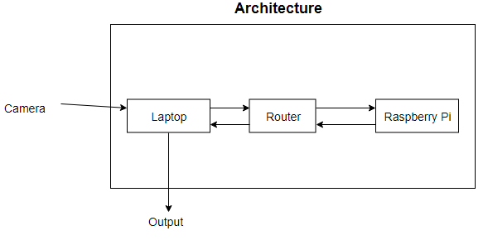

## Top Level Design

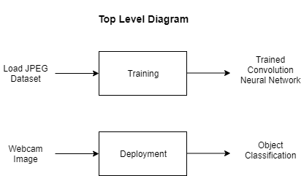

## Level (1) Design

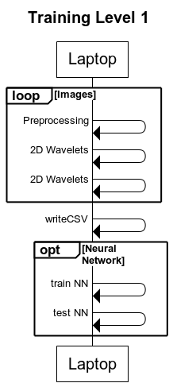

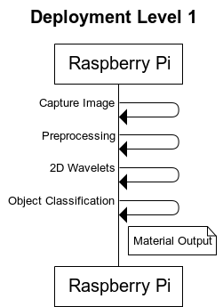

## Level (2) Design

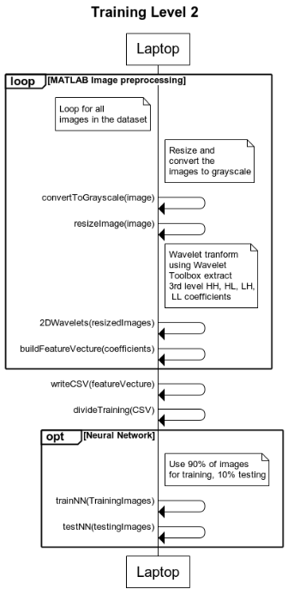

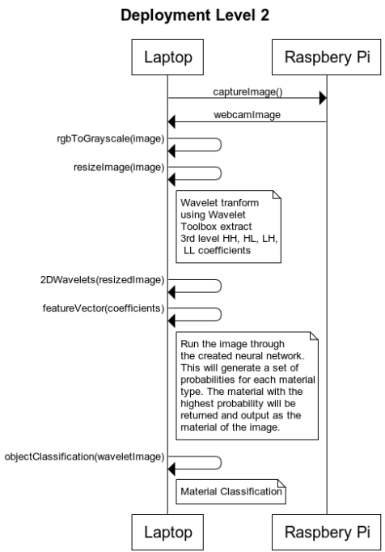

# References

[1] [Online]. Available at:<https://www.mathworks.com/hardware-support/matlab-webcam.html>

[2] [Online] Available at: <https://www.mathworks.com/products/wavelet.html>

[3] [Online] Available at: <https://aws.amazon.com/tensorflow/>

[4] [Online] Flickr Material Database (FMD)

L. Sharan, R. Rosenholtz, and E. H. Adelson, "Accuracy and speed of material categorization in real-world images", Journal of Vision, vol. 14, no. 9, article 12, 2014. Available at: <https://people.csail.mit.edu/lavanya/fmd.html>